TOLL GATE SYSTEM

# A MINI PROJECT REPORT

*Submitted by*

# VARSHINI.S (2116210701302)

***in partial fulfilment of the award of the degree***

***of***

# BACHELOR OF ENGINEERING

**IN**

# COMPUTER SCIENCE AND ENGINEERING



**RAJALAKSHMI ENGINEERING COLLEGE AUTONOMOUS, CHENNAI 602 105**

**MAY 2024**

# BONAFIDE CERTIFICATE

Certified that this project report **“TOLL GATE SYSTEM”** is the bona-fide work of **“VARSHINI.S (210701302)”** who carried out the project work under my supervision. Certified further that to the best of my knowledge the work reported herein does not form part of any other thesis or dissertation on the basis of which a degree or award was conferred on an earlier occasion on this or any other candidate.

**Ms. S. Ponmani M.E.,MBA,**

## SUPERVISOR

Assistant Professor

Department of Computer Science and Engineering Rajalakshmi Engineering College

Chennai - 602105

Submitted to Project Viva-Voce Examination held on .

Internal Examiner External Examiner

## ABSTRACT

The Toll Gate System project uses an Arduino microcontroller, an ultrasonic sensor and a servo motor to automate toll gate operations. It is designed to increase efficiency and convenience in vehicle passage through toll gates. The main elements include the Arduino board, ultrasonic sensor, servo motor, breadboard and jumper wires.

The approaching of the car is detected by the ultrasonic sensor. When a vehicle comes within a certain distance of it, the sensor sends a signal to Arduino that processes this information and opens the gate by turning on its servomotor so that this car can pass through it. After the car exits from the range of this sensor, Arduino signals back servomotor to close it and reset everything for other cars.

This project demonstrates how microcontroller technology can solve real-life problems. The system decreases manual intervention in operating tolls thereby increasing vehicle flow rates and reducing delays at toll stations or points. For managing traffic movement across tollgates effectively, Toll Gate System emphasizes how such automation based on Arduino holds promise in enhancing day-to-day activities providing dependable solution with high effectiveness.

# ACKNOWLEDGMENT

First, we thank the almighty God for the successful completion of the project. Our sincere thanks to our chairman **Mr. S. Meganathan, B.E., F.I.E.,** for his sincere endeavor in educating us in his premier institution. We would like to express our deep gratitude to our beloved Chairperson **Dr. Thangam Meganathan, Ph.D.,** for her enthusiastic motivation which inspired us a lot in completing this project, and Vice-Chairman **Mr. Abhay Shankar Meganthan**, **B.E., M.S.,** for providing us with the requisite infrastructure. We also express our sincere gratitude to our college principal, **Dr.S.N.Murugesan M.E., PhD.,** and **Dr. P. Kumar M.E., Ph.D., Head of the Department of Computer Science and Engineering,** and our project guide **Ms. S. Ponmani M.E.,MBA,** for her encouragement and guiding us throughout the project. We would like to thank our parents, friends, all faculty members, and supporting staff for their direct and indirect involvement in the successful completion of the project for their encouragement and support.

.

**TABLE OF CONTENTS**

|  |  |  |
| --- | --- | --- |
| **CHAPTER NO** | **TITLE** | **PAGE NO** |
| **1** | **INTRODUCTION** | 1 |
| **2** | **LITERATURE SURVEY** | 2 |
| 2.1 | EXISTING SYSTEM | 3 |
| **3** | **PROJECT DESCRIPTION** | 4 |
| 3.1 | PROPOSED SYSTEM | 6 |
| 3.2 | REQUIREMENTS | 6 |
| 3.2.1 | HARDWARE REQUIREMENTS | 6 |
| 3.2.2 | SOFTWARE REQUIREMENTS | 6 |
| 3.3 | ARCHITECTURE DIAGRAM | 7 |
| 3.4 | OUTPUT | 8 |
| **4** | **CONCLUSION AND FUTURE WORK** | 11 |
|  | **APPENDICES** | 12 |
|  | **REFERENCE** | 14 |

# CHAPTER 1 INTRODUCTION

The objective of the Toll Gate System project is automating toll booth activities through the Arduino based setup. It involves an Arduino microcontroller, ultrasonic sensor, servo motor, breadboard and jumper wires. This mechanism has improved efficiency thus reducing human intervention.

This device uses ultrasonic sensors to detect nearby vehicles. When a car approaches within a set distance, the signal goes to Arduino from the sensor. The waveform by the ultrasonic sensor then activates a gate-opening servo motor in response to one’s vehicle passing out. On reaching beyond this range, the absence of voltage triggers closing mechanism of the gate via servo-motor by which it was opened for a particular car. Therefore once this happens it ensures that the gate is ready for another vehicle.

In addition to streamlining toll collection process, automation also relieves traffic congestions at tollgates while improving free flow of vehicles at toll plazas. Thus as such projects are made using widely available and low cost items such as Arduino, Ultrasonic Sensor or Servo Motor; they can be utilized very easily for real life applications in any place. This system represents an easy but effective way of modernizing collection operations at toll booths.

# CHAPTER 2 LITERATURE SURVEY

[1] The automated toll collection system is a relatively recent piece of technology that has the potential to collect tolls in a manner that is both more efficient and expedient. It is an excellent alternative to the requirement of having to wait for a considerable length of time at manual toll plazas. A toll collection system that is based on RFID technology was built with the help of the Raspberry Pi. [2] Transportation technology plays a vital role in people's lives, one of which is trains. The role of transportation has many positive impacts, but there are also many other negative impacts, one of which is an accident due to the manual operation of the rail junction gate. This work aims to build an automatic system that can control train gate junctions without an operator and sense based on train schedule with an additional sensor for detection of a train passing . [3] In this study the tool used is in the form of a miniature as an implementation of automatic railroad doors to facilitate work in operating railroad doors which currently still require a lot of staff so that errors often occur due to negligence in operating which causes accidents on railroad crossings. fire. In this study, it will be designed using a motion sensor to detect the movement of a train if it is running and an ultrasonic sensor to measure the distance of a train whether it is approaching the railroad crossing. How the tool works is made by utilizing Arduino Uno and ultrasonic sensors as data input providers.

# 2.1 EXISTING SYSTEM

The toll gate system in place uses a combination of Arduino-based setup, an ultrasonic sensor and a servo motor to automate the operations of opening and closing gates. The main parts that make up this system include an Arduino board, HC-SR04 ultrasonic sensor, breadboard, SG90 servo motor as well as jumper wires for connections.

In the event that a vehicle approaches the toll gate, its presence is detected by the ultrasonic sensor which measures distance. Once this measurement goes below a particular predetermined threshold at which it can be inferred that there is a car nearby, then the Arduino applies power to the servo

motor and opens up the gate. Afterward when no longer having any object within such limited distance as perceived by sensor and so on then Arduino will tell servo close down and it will close.

Traditional toll systems are usually based on manual approach or expensive technology such as RFID tags or ANPR (Automatic Number Plate Recognition) and toll collectors making them costly and inefficient. On the other hand, this sort of approach using Arduino offers an economical way of handling traffic flow through automatic gates thereby reducing need for human intervention hence low operation costs. However, although it may provide an affordable option, security issues and challenges related to scalability might not be dealt with here compared to sophisticated models.

# CHAPTER 3 PROJECT DESCRIPTION

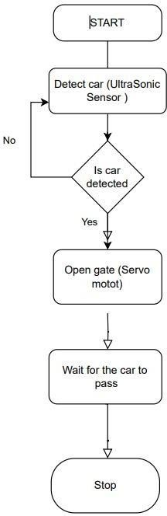

### Figure 1

The object of this project is to develop an automated toll gate system by using Arduino, ultrasonic sensor, servo motor, breadboard and jumper wires. The car presence in the system is detected and then it opens the gate automatically; thus minimizing manual labor and maximizing efficiency.

### System Workflow:

* Start: System starts up and enters into a monitoring state.
* Detect Car (Ultrasonic Sensor): It is kept under continuous monitoring for any car coming towards the gate.
* Is Car Detected?: In case there is a car within some set distance, open gate. Otherwise keep on monitoring.
* Open Gate (Servo Motor): Servo motor rotates to open the gate.
* Wait for the Car to Pass: The system will wait for the car to pass over its sensor.
* Close Gate (Servo Motor): After that, when the vehicle has left already, it closes it with a servo motor.
* Stop: When this happens, go back to initial monitor mode waiting for next car identification.

Figure 1 illustrates how this process works starting from determining whether there is a car until closing of gates being controlled via cars sensors.

This automated tollgate system provides an economical and effective solution to managing toll stations. This reduces human intervention as well as enhances movement at such places.

## PROPOSED SYSTEM

An Arduino, a servo-motor and an ultrasonic sensor are combined in the suggested toll gate system that would open and close a barrier automatically. One main component of this system is an Arduino board; while HC-SR04 ultrasonic sensor; SG90 servo motor; breadboard and jumper wires make up other essential parts.

When a car reaches the gate it’s presence is detected by the ultrasonic sensor by measuring the distance. If the car comes within range, arduino then triggers the servo to open the gate. When there is no more object in front of its sensor for that specified distance, it closes the door again.

This middle-of-the-road toll system dispenses with manualism or expensive equipment like RFID and ANPR (Automatic Number Plate Recognition) unlike traditional toll systems. It does not put too much pressure on cashiers and speeds up their actions making it perfect for small- or medium- sized toll operations.

It can be relied upon to offer automated toll booth operation that is easy to deploy with plans for further refinements such as integrating payment systems or adding more sensors to improve accuracy. The adoption of this approach makes collection process at tills faster thereby cutting costs related to both time wasted by drivers waiting in queues before payment.

## REQUIREMENTS

* + 1. **HARDWARE REQUIREMENTS**
  + Arduino
  + Ultrasonic Sensor
  + Power Supply
  + Jumper Wires
  + Servo Motor
  + read Borad
    1. **SOFTWARE REQUIREMENTS**
  + Arduino IDE

## ARCHITECTURE DIAGRAM

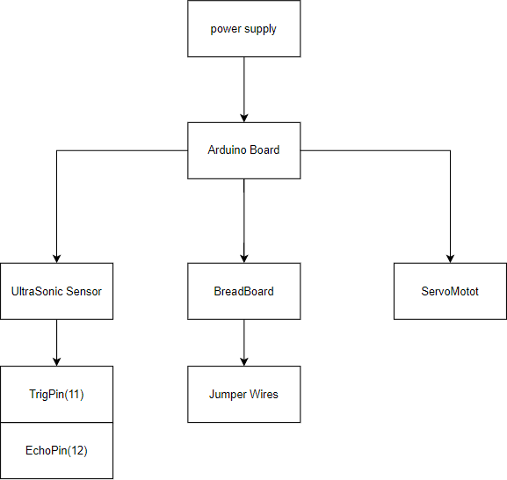

### Figure 2

The proposed system for a toll gate automates the opening and closing of a gate, using an Arduino, ultrasonic sensor and servo motor. The components of this system include an Arduino board, HC-SR04 ultrasonic sensor, SG90 servo motor, breadboard and jumper wires.

## Component :

* **Power Supply**: It supplies power to the Arduino as well as its connected components.
* **Arduino Board**: It acts as the central controller that manages the ultrasonic sensor and servo motor.
* **Ultrasonic Sensor (HC-SR04):** This can detect the presence of a car by producing ultrasonic pulses then obtaining how much time it will take for an echo to return. Connected to the arduino with:
* **Trig Pin (D11):** This sends out ultra sonic pulses.
* **Echo Pin (D12):** This receives back reflected pulses.
* **Servo Motor (SG90):** It controls movement of the gate connected with PWM control to digital pin D6 on arduino.
* **Breadboard**: For organizing connections in circuit
* **Jumper Wires**: These connectors assist in linking different parts together

## Process:

* **Detection**: This is when the ultrasonic sensor waits for any approaching vehicle. The moment it detects a car within a range defined by it ,the sensor sends a signal to arduino .
* **Processing**: As soon as distances are computed by Arduino based on readings from sensors; if our car is at a distance not beyond set limit, signals are sent to servo motor so that gate opens wide enough for entry .
* **Gate Operation**: When opening moves aside since of this machine’s activity.

## OUTPUT

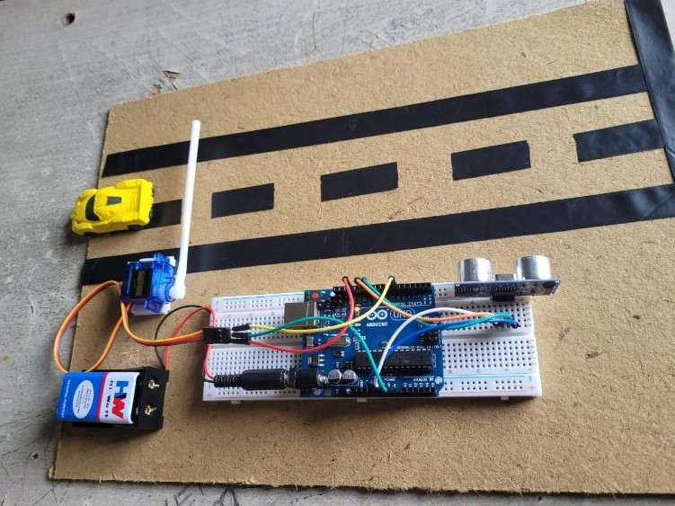

### Figure 3

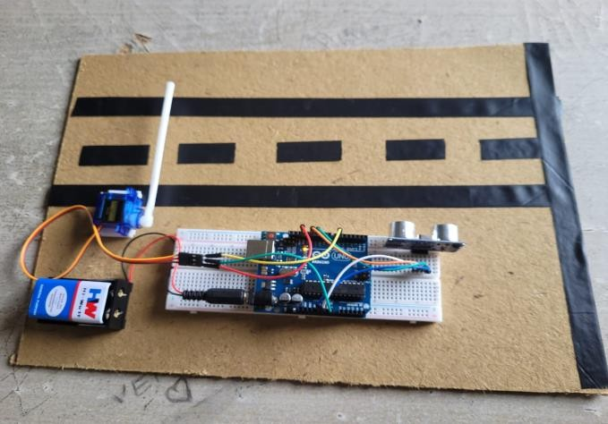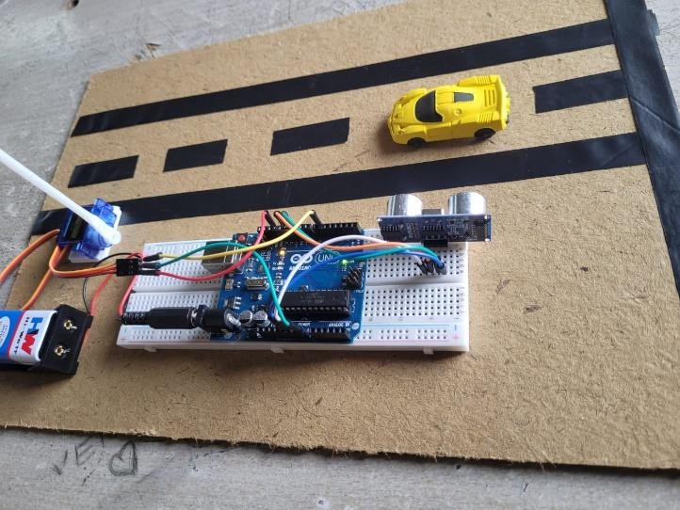

Figure 3 is the output of real time , the car is sense through the ultrasonic sensor and the gate is opened and when the car moves the gate is closed

**CONNECTIONS:**

### Figure 4

Figure 4 shows the connections made to the Arduino to UltraSonic Sensor .The connections are provided as specified in the architecture.

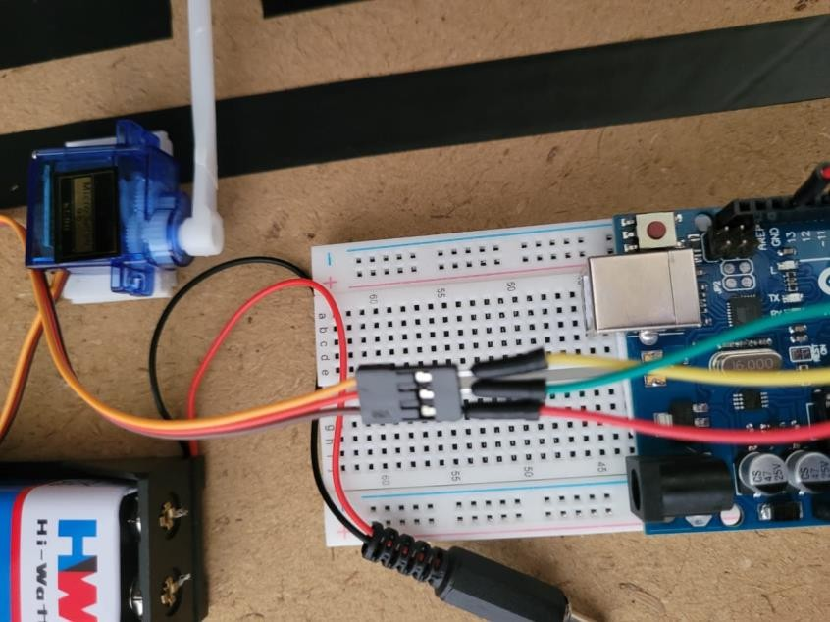

### Figure 5

Figure 5 shows the connections made to the Arduino to Servo Motor .The connections are provided as specified in the architecture.

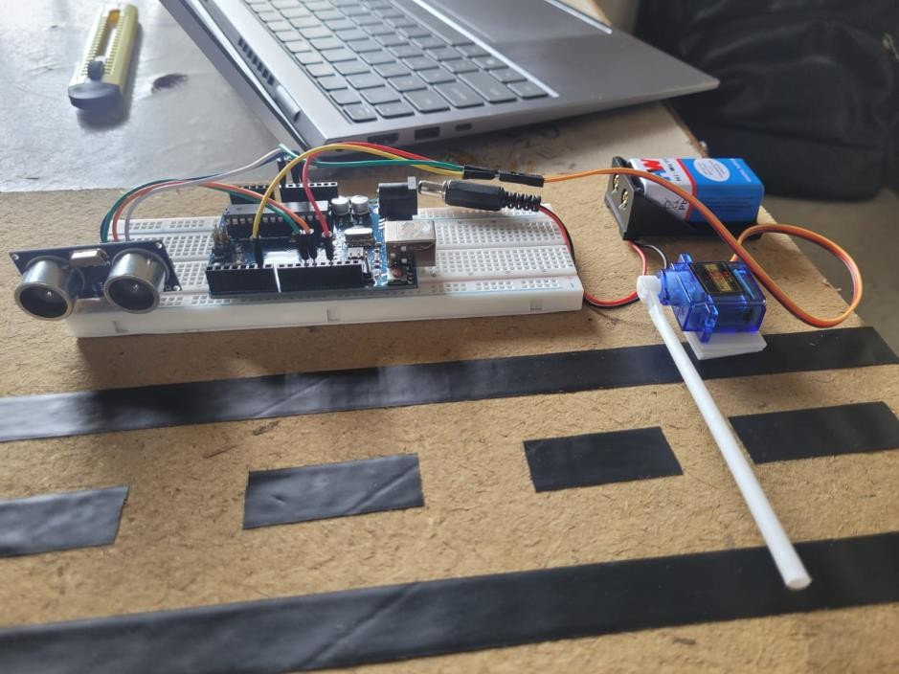

### Figure 6

Figure 6 depicts the ULTRASONIC SENSOR which is ready to scan and work as intended in the above sections.

## CHAPTER 4 CONCLUSION AND FUTURE WORK

Thus, implementation of an Arduino-based tollgate system is a cost-effective solution that increases efficiency at the booth. By using ultrasonic sensors to detect cars and servo motors to control gates, it eradicates the need for manual operations easing the collection of toll fees. This method tackles inefficiencies and high running costs associated with customary toll systems while providing a simple yet efficient solution to contemporary toll management.

A few modifications need to be done in future to make the system more functional and robust. First, integration of additional detectors such as RFID readers can enable this system to manage electronic tolls thus avoiding use of physical booths for collecting such levies. Second, solar panels or other renewable energy sources may enhance this system’s sustainability by reducing dependence on outside power supply. Furthermore, there could be development of mobile applications that are used in monitoring and controlling the gate in real time which will enhance convenience among operators. Finally, introduction of machine learning algorithms that analyze movement trends to predict peak moments would optimize gate performance further improving overall productivity .

# APPENDIX I

#include <Servo.h>

// Define the pins for the ultrasonic sensor const int trigPin = 11;

const int echoPin = 12;

// Define the pin for the servo motor const int servoPin = 6;

// Create a Servo object Servo gateServo;

// Define the distance threshold in centimeters

const int distanceThreshold = 10; // Adjust this value as needed

void setup() {

// Initialize the serial communication Serial.begin(9600);

// Set the ultrasonic sensor pins as output and input pinMode(trigPin, OUTPUT);

pinMode(echoPin, INPUT);

// Attach the servo to the defined pin gateServo.attach(servoPin);

// Set the initial position of the servo (gate closed) gateServo.write(0); // 0 degrees

}

void loop() {

// Get the distance from the ultrasonic sensor

long duration, distance; digitalWrite(trigPin, LOW); delayMicroseconds(2); digitalWrite(trigPin, HIGH); delayMicroseconds(10); digitalWrite(trigPin, LOW); duration = pulseIn(echoPin, HIGH); distance = (duration / 2) / 29.1;

// Print the distance to the Serial Monitor Serial.print("Distance: "); Serial.print(distance);

Serial.println(" cm");

// Check if the distance is less than the threshold if (distance < distanceThreshold) {

// Open the gate (move the servo to 90 degrees) gateServo.write(90);

Serial.println("Gate Open");

} else {

// Close the gate (move the servo to 0 degrees) gateServo.write(0);

Serial.println("Gate Closed");

}

// Small delay to prevent bouncing delay(1000);

}

**REFERENCE**

1. An IOT-Based Automotive and Intelligent Toll Gate Using RFID

S Chandrappa, MS Guruprasad, HNN Kumar… - SN Computer …, 2023

1. Soumil IntegrationSimulationofIoT Based Scheduled RailwayGate(Case Study: 2 RailwayGate)

KRahmawati- 2022

1. Automatic Train Junction Gate Control System Based on Arduino-Uno Microcontroller OY Barokah, MA Roidbafi - International Journal of Scientific …, 2021
2. Empty Parking Tracking System using Internet of Things (IoT) MFM Sabri, MH Zohari, MS Zainal - … and Electronic Systems, 2021
3. Design of Water Level Monitoring using Ultrasonic Sensor

HA Baskhara, S Anwar - Journal of Physics: Conference Series, 2021

1. The automatic and manual railroad door systems based on IoT

S Budiyanto, FA Silaban, LM Silalahi… - Indonesian Journal of …, 2021

1. Design and control system of sluice gate with web-based information IGMN Desnanjaya, IMA Nugraha - … and Information Systems …, 2021
2. AUTOMATIC TOLL GATE SYSTEM B SANGIVALASA - 2020.
3. Implementation Of Railway Doors Using Vibration Sensors And Ultrasonic Sensors Based On Arduino Uno

MS Novelan, U Mariance - INFOKUM, 2022

1. Automation of rail gate control with obstacle detection and real time tracking in the development of Bangladesh railway

KBQ Chowdhury, MR Khan… - 2020 IEEE 8th R10 …, 2020